Annotated Bibliography

Alotaibi, M. S. (2024). Game-based learning in early childhood education: a systematic review and meta-analysis. Frontiers in Psychology, 15, 1307881. https://doi.org/10.3389/fpsyg.2024.1307881
Since we determined that a school-based educational program would be expensive, difficult to implement, and ineffective at engaging children, we had the idea to create a video-game. Aloltaibi’s synthesized review of the benefits associated with game-based learning in early education provided us with concrete evidence that designing and developing a video game would be an effective and accessible solution to teaching children about data privacy and surveillance. Alotaibi’s analysis found that game-based learning significantly increases children’s motivation to understand various educational topics by providing instant feedback and rewards. It was also found that game-based learning provides children with a sense of autonomy and competence in completing gamified tasks, leading to higher levels of engagement and motivation. By understanding the ways in which game-based learning enhances educational engagement and motivation among children, Alotaibi’s research solidified our idea that developing an educational video game would be an effective way to address our problem.

Finkelhor, D., Jones, L., & Mitchell, K. (2021). Teaching Privacy: A flawed strategy for children’s online safety. Child Abuse & Neglect, 117. https://www.sciencedirect.com/science/article/pii/S014521342100137X#bbib0195
Teaching Privacy: A flawed strategy for children’s online safety was used to help identify gaps in current educational programs related to privacy, guiding the development of our solution that aims to address what existing educational programs on children's digital privacy does not. Here, the authors highlight the issues present in privacy education towards children, arguing that current teachings of the topic are misguided. Privacy is often presented as an abstract concept to children, making it difficult for children to conceptualize what exactly privacy means. Given that the meaning of privacy can differ in various situations, children must be taught about privacy in-relation to the context of situations. When children are taught about privacy, educators often fail to explain context-specific harms and what steps children can take to mitigate them. As a result, children are taught general rules about “protecting privacy” without understanding who they are protecting themselves from, how they can protect their privacy, and why protecting their privacy matters. The authors suggest that educators need to shift the focus of privacy from general rules (e.g., do not share your passwords with others) to helping children understand context-specific privacy risks they face and how to address them effectively.

Kumar, P., & Hyde, L. (2023). EXPLORING HOW U.S. K-12 EDUCATION ADDRESSES PRIVACY LITERACY. AoIR Selected Papers of Internet Research. https://doi.org/10.5210/spir.v2023i0.13439
In order to identify gaps in current privacy education, Pryia Kumar and Lily Hade’s research provided a comprehensive overview of current educational privacy standards in K-12 education within the United States. Similar to our project inspiration, the researcher ground the relevance of their research in the fact the concept of privacy literacy is quickly evolving as digital technologies infiltrate the lives of children and young-adults. Kumar and Hade defined their method of analysis by specifically evaluating standards taught to all students, not just those enrolled in elective courses. As of 2024, only 44 states have implemented educational standards related to privacy while only 36 explicitly mention privacy. Privacy is primarily discussed in computer science and social studies courses where privacy is framed in relation to ethical issues and general privacy practices (e.g., how students can protect their personal information). Kumar and Hade conclude that the standard approach to privacy education is instructing students on “what not to do,” which pedagogical research advises educators against. Based on these findings, we designed our game-play to teach students about concrete strategies they can take to protect themselves in digital environments where privacy and surveillance harms can occur.

Mcclain, C., Faverio, M., Anderson, M., & Park, E. (2025, October). How Parents Manage Screen Time for Kids. Pew Research Center. https://www.pewresearch.org/internet/2025/10/08/how-parents-manage-screen-time-for-kids/
While it is evident that children are increasingly using digital technology in their everyday lives, we wanted to ground our problem in statistical evidence that establishes just how much children are using everyday technology that COPPA does not regulate. In 2025, Pew Research Center collected survey data from 3,054 parents who have children under the age of 12, asking these parents about their children’s access to and use of digital devices, online platforms, and other technologies. Based on responses from research participants, it was found that 68% of their children have their own smart-tablet, 61% of these children use a smart-phone, and roughly 40% use voice assistants such as Apple’s Siri or Amazon’s Alexa. The data here established our claims that as children use and engage with technology, they are vulnerable to becoming surveilled and datafied.
Sandoval, M. (2024, August). Child Privacy in the Digital Era: Is COPPA Enough? Digital Commons at American University College of Law. https://digitalcommons.wcl.american.edu/cgi/viewcontent.cgi?article=1132&context=research
Melannie Sandoval’s legal research on the effectiveness of the Children's Online Privacy Protection ACT (COPPA) helped us understand how the U.S. federal government protects, and sometimes fails to protect, children’s privacy in our digitalized society. Sandoval provides a high-level overview of COPPA, describing how COPPA safeguards children’s data privacy when data is collected by online goods/services that target children under the age of thirteen. However, Shavel argues that COPPA fails to acknowledge the growing presence of children online and the harms associated with it such as, the monetization of children’s data, data breaches containing children's personal information, and interacting with online predators unknowingly. By understanding where COPPA falls short, we designed our game to educate children on how to protect themselves and their privacy in the situational contexts that COPPA does not protect against.

Girouard-Hallam, L. (2025, October). Lecture 9: Privacy, Surveillance, Technology, & Childhood Development. University of Michigan.
Dr. Girouard-Hallam’s lecture on technology and childhood development focused on how children interact with the digital world, often without proper education or guidance. She explained that children are using the internet at an exceedingly higher rate than ever before, and often receiving only surface level education that leaves major gaps in their understanding and perception of online safety. Her critique of existing educational resources like Faux Paw - Adventures in the Internet highlighted the main shortcoming: current programs often provide mere facts and simplistic warnings rather than in-depth and engaging instruction. Dr. Girouard-Hallam also mentioned that many children view AI voice assistants such as Siri and Alexa as friends, unaware of potential privacy risks. This lecture was crucial for developing the Privapal’s concept, as it showcased where most education programs fail when it comes to properly educating the youth.

Sinha, D. (2024, July). COPPA Compliance: How to design COPPA compliant mobile apps for kids. TechAhead. https://www.techaheadcorp.com/blog/coppa-compliance/
While Sandoval’s article provided a high-level overview of what COPPA entails and what it fails to protect children from, Sinha’s article offered a more practical, developer-focused guide to achieving COPPA compliance in mobile app development. Given that our gaming solution is intended for children between the ages of 9 to 13, we used Shina's article to address the ways our game would be COPPA compliant: obtaining verifiable parental consent (which would be gamified for children to learn why it is important), collecting minimal data that is not required for game-play, and never monetizing children’s behavioral data.

United Nations Children’s Fund. (2024, April). Video games can have a positive impact on children – if they are designed right, says new study. UNICEF. https://www.unicef.org/innocenti/press-releases/video-games-can-have-positive-impact-children-if-they-are-designed-right-says-new
In order to further verify that game-based learning is an effective pedagogical tool, research sponsored by UNICEF provided us with additional evidence that supported our decision to develop a mobile and desktop gaming solution. The research, which was conducted by four global universities showed that when children have a sense of autonomy during game-play, it allows them to be in-control which enables them to learn how to make decisions and develop their own strategies for solving problems. Based on this evidence we decided that our game-play mechanics should center on social-simulation games as it enables children to exercise agency by navigating privacy and surveillance, allowing them to learn how everyday digital decisions impact their safety online.

Valcke, M., De Wever, B., Van Keer, H., & Schellens, T. (2011). Long-term study of safe Internet use of young children. Computers & Education, 57(1). https://doi.org/10.1016/j.compedu.2011.01.010
Valcke, De Wever, Van Keer, and Schellens used this journal to present their findings on a long-term study focused on understanding how children’s online behavior changes as they age. In the study, they looked at how outside influences such as income, parental and teacher supervision, awareness campaigns, and age affected use patterns - all of which were incredibly relevant for our problem solving. The study showed that while children improved in online safety habits such as stronger passwords and avoiding links that look suspicious, they still fell short in many other areas. This suggests that many children fail to continue learning about more complex online dangers, beyond those taught at an early age. The findings of this study ultimately led to designing the game with recurring scenarios that revisit prior knowledge over time, reinforcing earlier lessons while still teaching players new and more advanced concepts.

Zhao, J., Wang, G., Dally, C., Slovak, P., Edbrooke-Childs, J., Van Kleek, M., & Shadbolt, N. (2019). `I make up a silly name’ Understanding Children’s Perception of Privacy Risks Online. In CHI Conference on Human Factors in Computing Systems Proceedings, 1–13. https://doi.org/10.1145/3290605.3300336
As our problem focused on the lack of educational resources that teach children about data privacy and surveillance, the research in `I make up a silly name’ Understanding Children’s Perception of Privacy Risks Online provides empirical evidence that was used to help us understand the contexts where children struggle to understand digital privacy and surveillance risks. In the researchers findings, children between the ages of six and ten were able to identify and articulate how to protect themselves from general privacy risks (e.g., oversharing information or explicit data requests). However, these children struggled to recognize and understand the risks associated with online data-tracking or targeted promotional data. The findings from this study directly informed the design of Privalpa, guiding the creation of gamified tasks that teach children how to navigate more complex digital privacy challenges.

A.I Addendum

Grace’s Use of A.I
For our project, I used ChatGPT Model 5 to help me rephrase sentences I had written myself but needed to be condensed for our class slide presentations in order to convey key points. To find key points in the research we analyzed, I conducted a literature review and synthesized commonalities on game-based learning and on privacy education through a thematic analysis. However, given that our slide presentation needed to provide a high level overview of our problem, our potential solution (and what it lacked), and how our solution accounted for these gaps, I broke down each problem solving step into a paragraph with the research I conducted and would ask ChatGPT to convert it into 3 to 5 key points and would select which ones fit each slide. Based on what ChatGPT provided, I would make changes accordingly (e.g., picking and choosing which key points best fit each slide and rewording these points in my own words). I also used ChatGPT to refine sentences I had written on my own for the summaries of research used for our Annotated Bibliography, I would only do this if I felt what I wrote was too lengthy and needed to be more concise.
Further, for our artifact (the video-game mockup), based on discussions with Eric and Sarafina about the game-play mechanics and what possible games we wanted to model our game on, we agreed on a game that took elements from Animal Crossing and Club Penguin Puffles. While I came up with the name “PrivaPals” on my own, ChatGPT was originally used to create a mock-up User-Interface screen that I gave to Sarafina to use as inspiration for the Figma mockup she would create. To do this, I prompted ChatGPT with the following: “Make me an iphone mockup of a video game called PrivaPal that has a character based on club penguin puffles and animal crossing where a dog called tom acts like tom-nook in animal crossing.” After a few iterations of asking ChatGPT to make adjustments in order to avoid possible copyright issues, I provided Sarafina with the final User-Interface screen inspiration for our final mockup we presented as our solution for our project. (See image down below).

Figure One - Final ChatGPT Mock-Up Used as Inspiration:
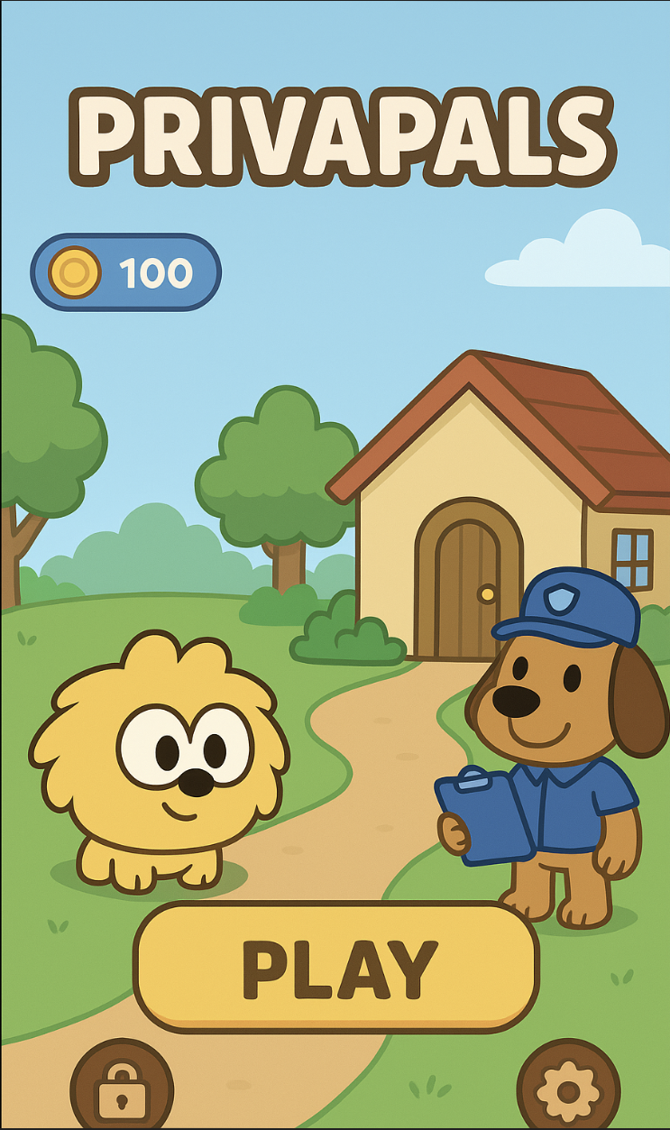

Sarafina’s Use of A.I
For the PrivaPals project, I served as the lead designer, and a major challenge was creating cohesive, child-friendly artwork for a mobile app without having an artist on our team. My workflow combined traditional design methods with AI-assisted rendering, but all AI outputs were heavily directed, corrected, and refined by me.
I began by hand-drawing initial mockups of key screens, especially the home screen, to establish layout, character style, and overall visual tone. I then explored color palettes in Figma to set the aesthetic direction. Once I had a clear visual concept, I used GPT to help render my sketches digitally. I provided the AI with my drawings and the exact color palette so it could produce a starting point that aligned with my design intent.
Because AI-generated art is often inconsistent, I treated these outputs strictly as rough drafts. I brought each image into Photoshop and manually refined them, correcting proportions, cleaning edges, matching styles across screens, and ensuring visual cohesion. Every final asset in our prototype went through this human-led editing process. For a production version of this app, I would absolutely hire a professional illustrator to develop a polished, original art system. The AI-assisted approach was used only to meet the scope and timeline of an academic prototype, and all creative direction, quality control, and final refinements were done by me.

Eric’s Use of A.I

I used artificial intelligence in several steps of this project. To begin, I used Claude AI to help our group formulate ideas regarding what an applicable solution would be to teach children about online privacy and safety. This prompt gave back several options, and we ultimately decided that an education plan for schools or a video game would be the best two (and most viable) options. Beyond that, our education plan idea and our video game concept reflect our original ideas.
Following the brainstorming step, artificial intelligence was also used to help us find sources. After we had settled on choosing a video game for our project, the same model of Claude helped us find reputable sources with information that supported our idea. For example, the journals from Alotaibi and Valcke were both derived from Claude prompts. That being said, we still looked into the qualifications of the authors, what organization published the journal, and if the data was relevant, without using AI tools.
Finally, Claude was also used in the creation of the slides. While all of the slide text, citations, and pictures were original work, Claude played a very important role in formatting, slide theming, and aesthetics. Rather than uploading a prompt, I uploaded pictures of the current slides and asked for ideas on how to improve the overall presentation. This was extremely beneficial, and contributed heavily to the professionalism and engagement for the slides.

